The Gown of Humility

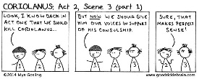
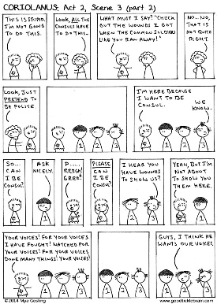

Long, long ago in a time before terrorist attacks (both foreign and domestic), Great Recessions, and pandemics, the original Weekend pioneers ventured forth to the Illinois Shakespeare Festival in Bloomington, Illinois. We were just a gang of plucky youth with the world on our string seeking out the fun and fashionable in America’s heartland.
We were treated to an evening performance of Shakespeare’s late period tragedy Coriolanus. The play relates the story of the title character, a brilliant general of the earliest time of the Roman Republic. Following a great military victory, he acquiesces to the entreaties of his mother – Oedipus alert – that he seek the consulship, the highest republican office. But Coriolanus, contemptuous of the plebians he seeks to rule, must first seek their approval --- while wearing a gown of humility!
The appearance of the actor alone on stage wearing little more than a short nightgown tickled our fancy and led to the now two-decade old tradition of bestowing on some unlucky Weekender the oft worn, never washed Gown of Humility.

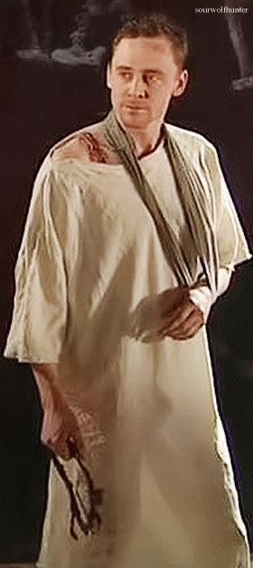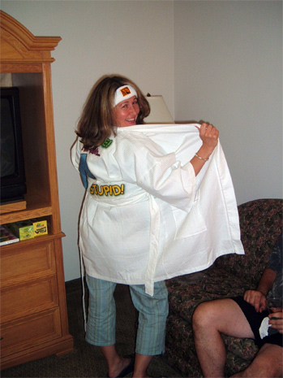

This evening, we will recreate a short portion of that inspirational performance.
Coriolanus, by William Shakespeare
ACT II, SCENE III. The Forum.
Enter seven or eight Citizens
First Citizen
Once, if he do require our voices, we ought not to deny him.
Second Citizen
We may, sir, if we will.
Third
We have power in ourselves to do it, but it is a
power that we have no power to do; for if he show us
his wounds and tell us his deeds, we are to put our
tongues into those wounds and speak for them; so,
he tell us his noble deeds, we must also tell him
our noble acceptance of them. Ingratitude is
monstrous, and for the multitude to be ingrateful,
were to make a monster of the multitude: of the
which we being members, should bring ourselves to be
monstrous members.
First Citizen
And to make us no better thought of, a little help
will serve; for once we stood up about the corn, he
himself stuck not to call us the many-headed multitude.
Third Citizen
We have been called so of many; not that our heads
are some brown, some black, some auburn, some bald,
but that our wits are so diversely coloured: and
truly I think if all our wits were to issue out of
one skull, they would fly east, west, north, south,
and their consent of one direct way should be at
once to all the points o' the compass.
Second Citizen
Think you so? Which way do you judge my wit would
fly?

Third Citizen
Nay, your wit will not so soon out as another man's
will;'tis strongly wedged up in a block-head, but
if it were at liberty, 'twould, sure, southward.
Second Citizen
Why that way?
Third Citizen
To lose itself in a fog, where being three parts
melted away with rotten dews, the fourth would return
for conscience sake, to help to get thee a wife.
Second Citizen
You are never without your tricks: you may, you may.
Third Citizen
Are you all resolved to give your voices? But
that's no matter, the greater part carries it. I
say, if he would incline to the people, there was
never a worthier man.
Enter CORIOLANUS in a gown of humility, with MENENIUS
Here he comes, and in the gown of humility: mark his
behavior. We are not to stay all together, but to
come by him where he stands, by ones, by twos, and
by threes. He's to make his requests by
particulars; wherein every one of us has a single
honour, in giving him our own voices with our own
tongues: therefore follow me, and I direct you how
you shall go by him.
All
Content, content.
Exeunt Citizens
MENENIUS
O sir, you are not right: have you not known
The worthiest men have done't?

CORIOLANUS
What must I say?
'I Pray, sir'--Plague upon't! I cannot bring
My tongue to such a pace:--'Look, sir, my wounds!
I got them in my country's service, when
Some certain of your brethren roar'd and ran
From the noise of our own drums.'
MENENIUS
O me, the gods!
You must not speak of that: you must desire them
To think upon you.
CORIOLANUS
Think upon me! hang 'em!
I would they would forget me, like the virtues
Which our divines lose by 'em.
MENENIUS
You'll mar all:
I'll leave you: pray you, speak to 'em, I pray you,
In wholesome manner.
Exit
CORIOLANUS
Bid them wash their faces
And keep their teeth clean.
Re-enter two of the Citizens
So, here comes a brace.
Re-enter a third Citizen
You know the cause, air, of my standing here.
Third Citizen
We do, sir; tell us what hath brought you to't.
CORIOLANUS
Mine own desert.
Second Citizen
Your own desert!
CORIOLANUS
Ay, but not mine own desire.
Third Citizen
How not your own desire?
CORIOLANUS
No, sir,'twas never my desire yet to trouble the
poor with begging.
Third Citizen
You must think, if we give you any thing, we hope to
gain by you.
CORIOLANUS
Well then, I pray, your price o' the consulship?
First Citizen
The price is to ask it kindly.
CORIOLANUS
Kindly! Sir, I pray, let me ha't: I have wounds to
show you, which shall be yours in private. Your
good voice, sir; what say you?
Second Citizen
You shall ha' it, worthy sir.
CORIOLANUS
A match, sir. There's in all two worthy voices
begged. I have your alms: adieu.
Third Citizen
But this is something odd.
Second Citizen
An 'twere to give again,--but 'tis no matter.
Exeunt the three Citizens
Re-enter two other Citizens

CORIOLANUS
Pray you now, if it may stand with the tune of your
voices that I may be consul, I have here the
customary gown.
Fourth Citizen
You have deserved nobly of your country, and you
have not deserved nobly.
CORIOLANUS
Your enigma?
Fourth Citizen
You have been a scourge to her enemies, you have
been a rod to her friends; you have not indeed loved
the common people.
CORIOLANUS
You should account me the more virtuous that I have
not been common in my love. I will, sir, flatter my
sworn brother, the people, to earn a dearer
estimation of them; 'tis a condition they account
gentle: and since the wisdom of their choice is
rather to have my hat than my heart, I will practise
the insinuating nod and be off to them most
counterfeitly; that is, sir, I will counterfeit the
bewitchment of some popular man and give it
bountiful to the desirers. Therefore, beseech you,
I may be consul.
Fifth Citizen
We hope to find you our friend; and therefore give
you our voices heartily.
Fourth Citizen
You have received many wounds for your country.
CORIOLANUS
I will not seal your knowledge with showing them. I
will make much of your voices, and so trouble you no further.
Both Citizens
The gods give you joy, sir, heartily!
Exeunt
CORIOLANUS
Most sweet voices!
Better it is to die, better to starve,
Than crave the hire which first we do deserve.
Why in this woolvish toge should I stand here,
To beg of Hob and Dick, that do appear,
Their needless vouches? Custom calls me to't:
What custom wills, in all things should we do't,
The dust on antique time would lie unswept,
And mountainous error be too highly heapt
For truth to o'er-peer. Rather than fool it so,
Let the high office and the honour go
To one that would do thus. I am half through;
The one part suffer'd, the other will I do.
Re-enter three Citizens more
Here come more voices.
Your voices: for your voices I have fought;
Watch'd for your voices; for Your voices bear
Of wounds two dozen odd; battles thrice six
I have seen and heard of; for your voices have
Done many things, some less, some more your voices:
Indeed I would be consul.
Sixth Citizen
He has done nobly, and cannot go without any honest
man's voice.
Seventh Citizen
Therefore let him be consul: the gods give him joy,
and make him good friend to the people!
All Citizens
Amen, amen. God save thee, noble consul!
Exeunt
CORIOLANUS
Worthy voices!
Re-enter MENENIUS, with BRUTUS and SICINIUS

MENENIUS
You have stood your limitation; and the tribunes
Endue you with the people's voice: remains
That, in the official marks invested, you
Anon do meet the senate.
CORIOLANUS
Is this done?
SICINIUS
The custom of request you have discharged:
The people do admit you, and are summon'd
To meet anon, upon your approbation.
CORIOLANUS
Where? at the senate-house?
SICINIUS
There, Coriolanus.
CORIOLANUS
May I change these garments?
SICINIUS
You may, sir.
CORIOLANUS
That I'll straight do; and, knowing myself again,
Repair to the senate-house.

